**Numerical Computation - Assignment 4**

**1930026143 薛劭杰**

**Q1.**

Initially, we can convert it to a matrix:

$3.03x1 - 12.1x2 + 14x3 = -119$ $[ 3.03 -12.1 14 -119$

$-3.03x1 + 12.1x2 - 7x3 = 120$ $⇒$ $-3.03 12.1 -7 120$

$6.11x1 - 14.2x2 + 21x3 = -139$ $6.11 -14.2 21 -139]$

𝐴 = $[ 3.03 -12.1 14$

$-3.03 12.1 -7$ and $b=\left[\begin{matrix}-119 \\ 120 \\ -139\end{matrix}\right]$

$6.11 -14.2 21$]

(a). $\left[A | B\right]=\left[\begin{matrix}3.03 & -12.1 & 14 \\ 0 & 0 & 7.00 \\ 0 & 10.1 & -7.10\end{matrix} \begin{matrix}-119 \\ 1.00 \\ 100\end{matrix}\right] through R_{2}+R_{1} and R_{3}-\frac{a_{31}}{a_{11}}R_{1}$

Exchange $R_{3} and R_{2} and$ we can get $\left[\begin{matrix}3.03 & -12.1 & 14 \\ 0 & 10.1 & -7.10 \\ 0 & 0 & 7.00\end{matrix} \begin{matrix}-119 \\ 100 \\ 1.00\end{matrix}\right]$

Using the back substitution and each calculation is cropping 3 digits left. We can get:

$x_{3}=\frac{1}{7}=0.142$

$x_{2}=\frac{100+0.142*7.10}{10.1}=10.0$

$x_{1}=\frac{-119+10.0*12.1-14*0.142}{3.03}=0.00660$

(b).

In the first column, $6.11>3.03=3.03$. So, Exchange $R_{3}$ to $R_{1}$.

$[A|b]=\left[\begin{matrix}6.11 & -14.2 & 21 \\ -3.03 & 12.1 & -7 \\ 3.03 & -12.1 & 14\end{matrix} \begin{matrix}-139 \\ 120 \\ -119\end{matrix}\right]$ through $R_{2}-\frac{a_{21}}{a_{11}}R_{1}$ and $R_{3}-\frac{a_{31}}{a_{11}}R_{1}$.

And we can get $\left[\begin{matrix}6.11 & -14.2 & 21 \\ 0 & 5.08 & 3.30 \\ 0 & -5.08 & 3.70\end{matrix} \begin{matrix}-139 \\ 51.2 \\ -50.2\end{matrix}\right]$

$\left|5.05\right|=\left|-5.05\right|$, there no need to exchange. Then through $R_{3}+R_{2}$, we can get:

$\left[\begin{matrix}6.11 & -14.2 & 21 \\ 0 & 5.08 & 3.30 \\ 0 & 0 & 7.00\end{matrix} \begin{matrix}-139 \\ 51.2 \\ 1.00\end{matrix}\right]$.

Using the back substitution and each calculation is cropping 3 digits left. We can get:

$x_{3}=\frac{1}{7.00}=0.142$

$x_{2}=\frac{51.2-3.30*0.142}{5.05}=9.98$

$x_{1}=\frac{-139-0.142*21+14.2*9.98}{6.11}=-0.160$

(c).

$scalar=\max\left(\left|-\frac{6.11}{14.2}\right|,\left|-\frac{3.03}{12.1}\right|, \left|-\frac{3.03}{-12.1}\right|\right)=\left|-\frac{6.11}{14.2}\right|=0.291→R_{3} exchange to R_{1}$.

$\left[A | b\right]=\left[\begin{matrix}6.11 & -14.2 & 21 \\ -3.03 & 12.1 & -7 \\ 3.03 & -12.1 & 14\end{matrix} \begin{matrix}-139 \\ 120 \\ -119\end{matrix}\right].$ Though $R_{2}-\frac{a_{21}}{a_{11}}R_{1}$ and $R_{3}-\frac{a_{31}}{a_{11}}R_{1}$, we can get $\left[\begin{matrix}6.11 & -14.2 & 21 \\ 0 & 5.06 & 3.40 \\ 0 & -5.06 & 3.60\end{matrix} \begin{matrix}-139 \\ 51.1 \\ -50.1\end{matrix}\right]$. $scalar=\max\left(\left|\frac{5.06}{5.06}\right|,\left|-\frac{5.06}{5.06}\right|\right)$ = $\left|\frac{5.06}{5.06}\right|$. So, we do not need to exchange two rows. Though $R_{3}+R_{2}$, we can get the final matrix: $\left[\begin{matrix}6.11 & -14.2 & 21 \\ 0 & 5.06 & 3.40 \\ 0 & 0 & 7.00\end{matrix} \begin{matrix}-139 \\ 51.1 \\ 1.00\end{matrix}\right]$.

Using the back substitution and each calculation is rounding 3 digits left. We can get:

$x_{3}=\frac{1}{7}=0.143$

$x_{2}=\frac{51.1-3.40*0.143}{5.06}=10.0$

$x_{1}=\frac{-139-0.143*21+14.2*10}{6.11}=0.00$

**Q2.**

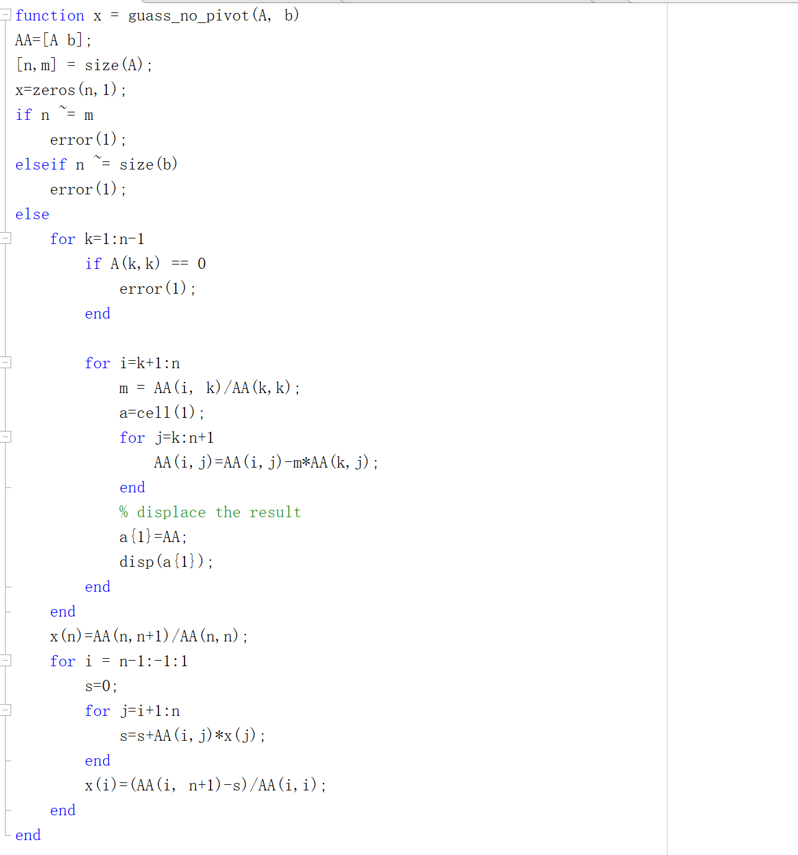

**Q3.**

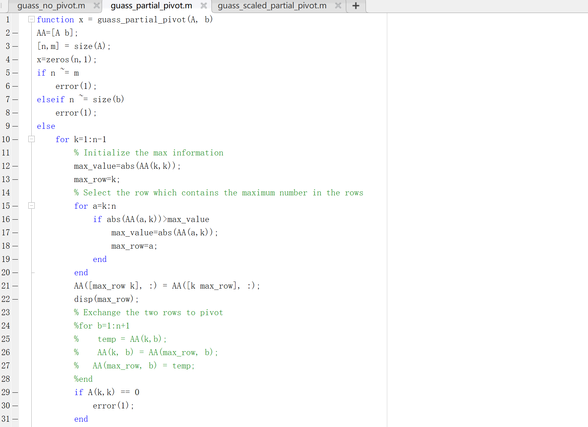

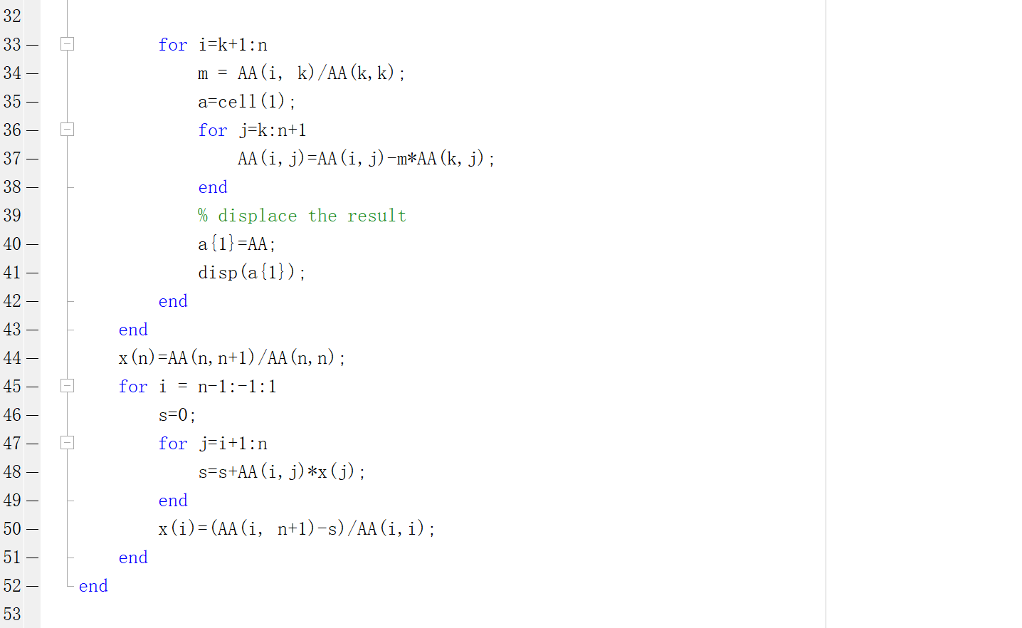

**Q4.**

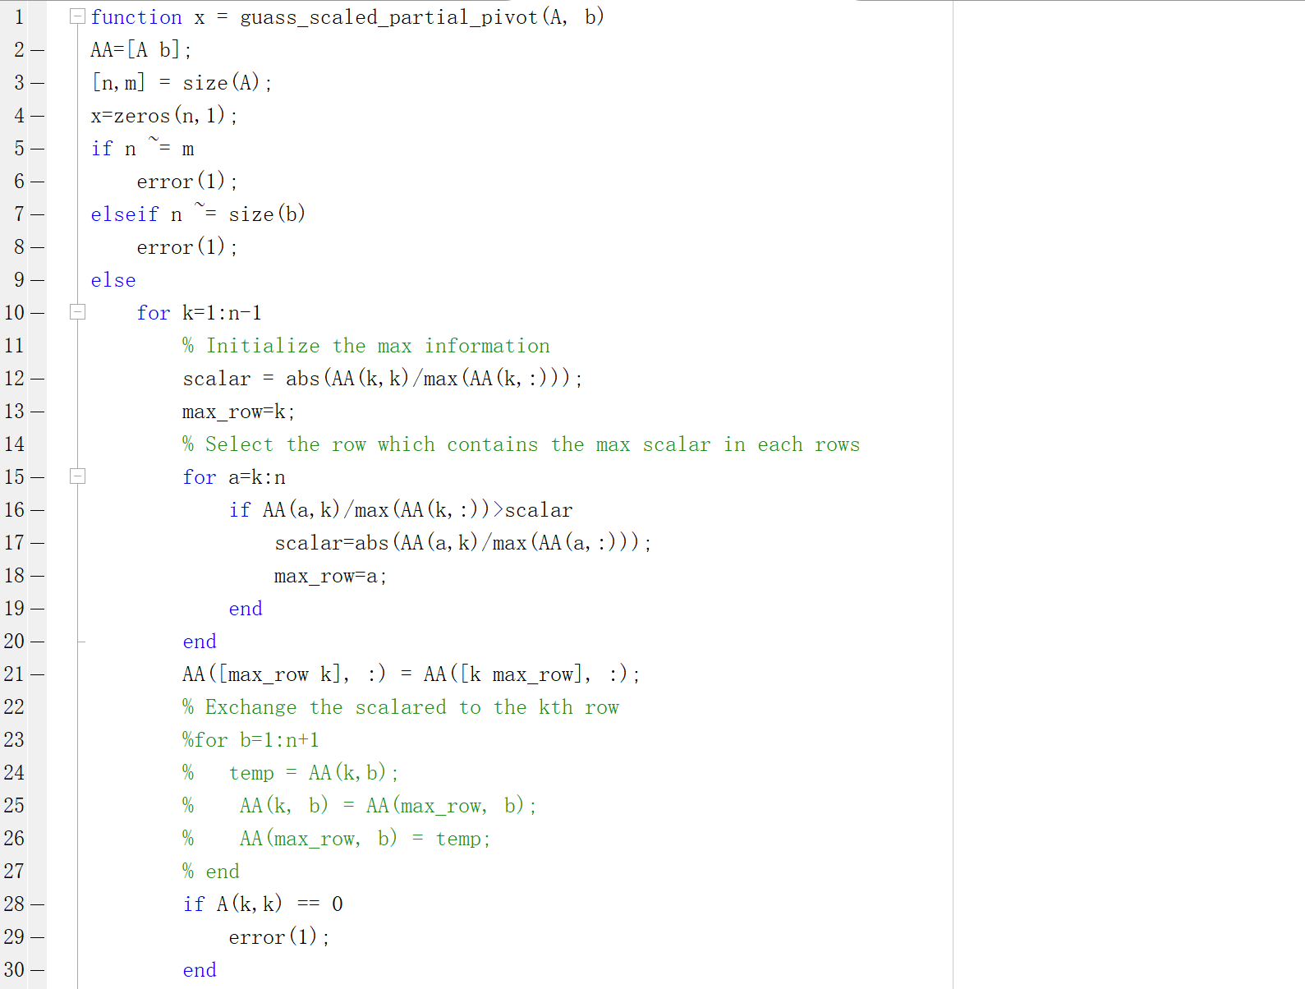

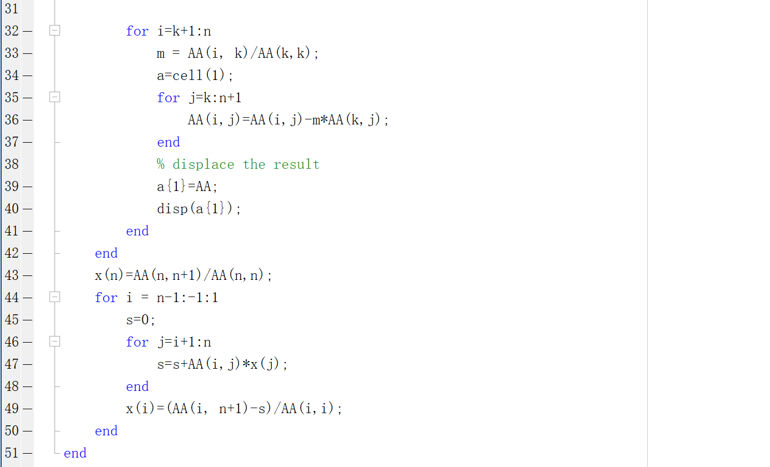

**Q5.**

$guass_no_oivot$:

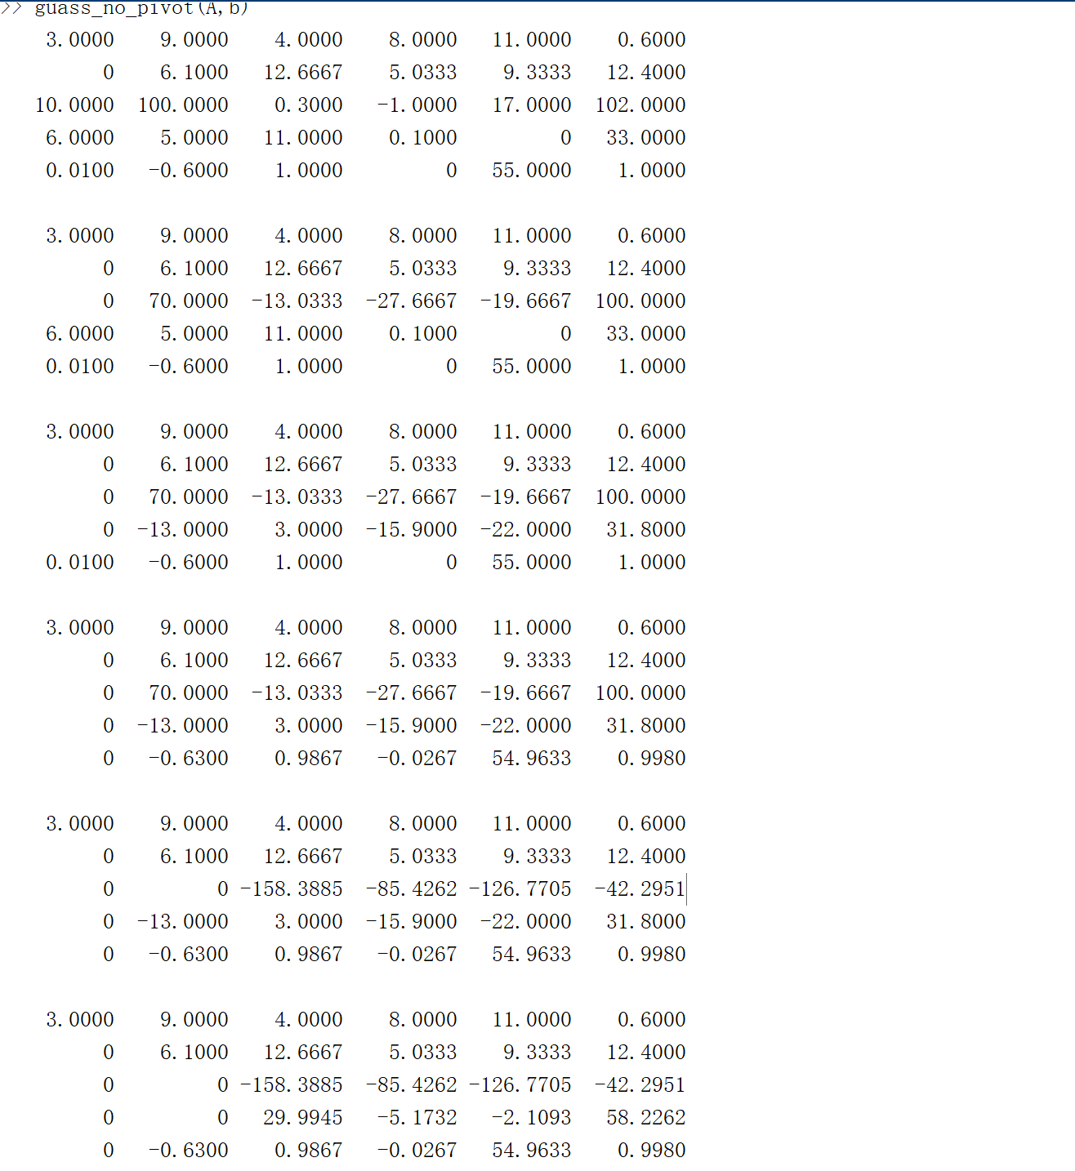

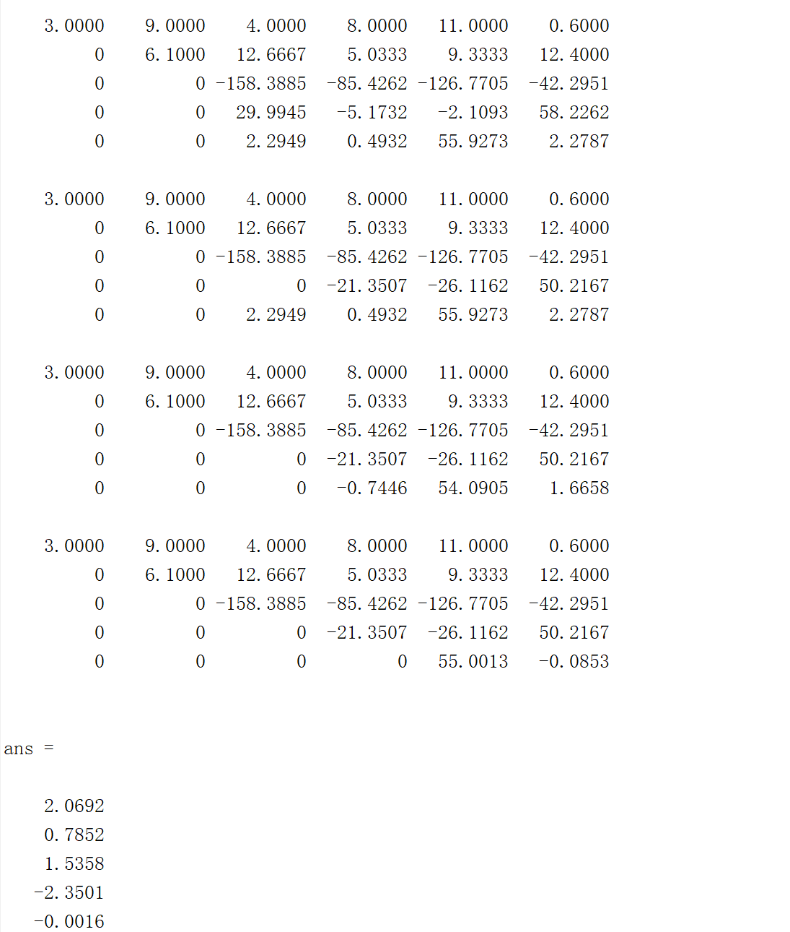

$guass_partition_pivot:$

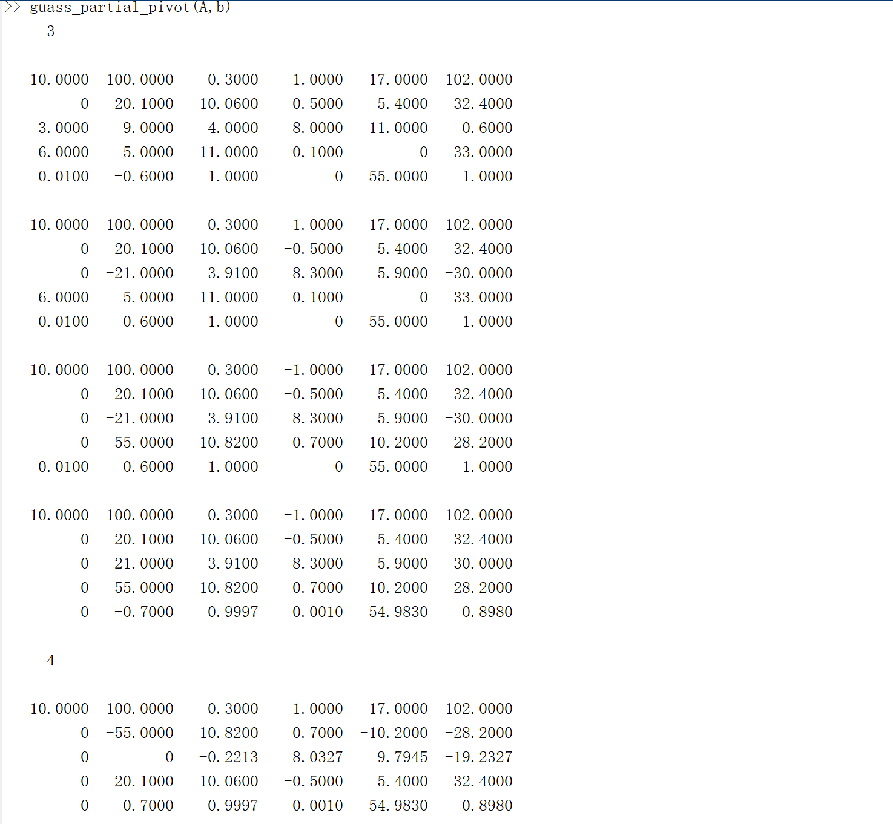

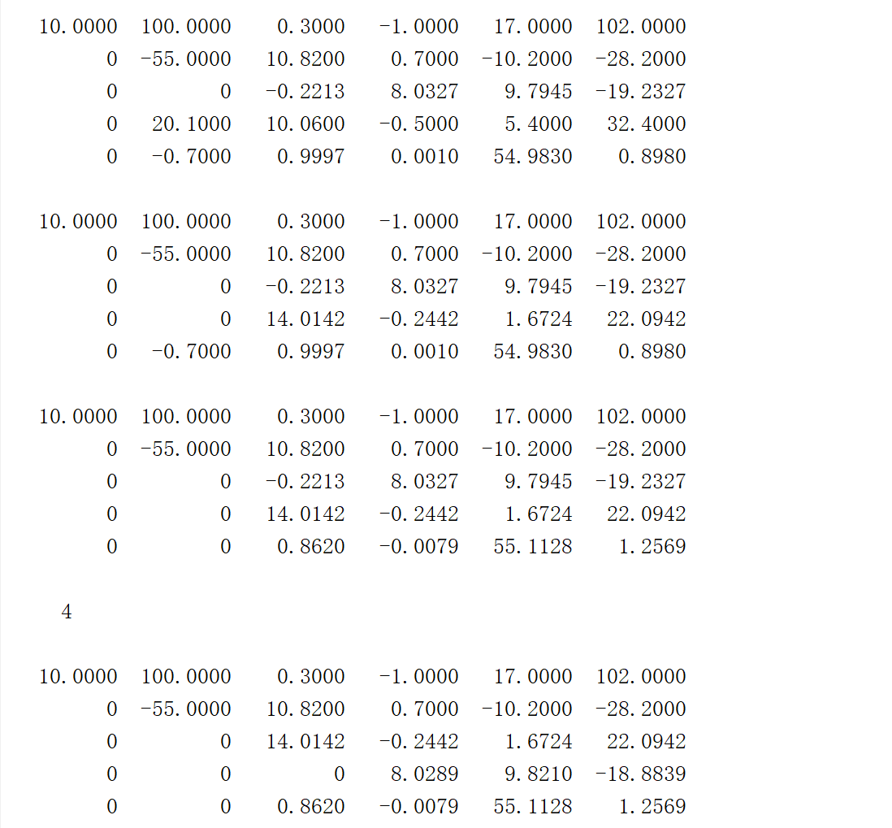

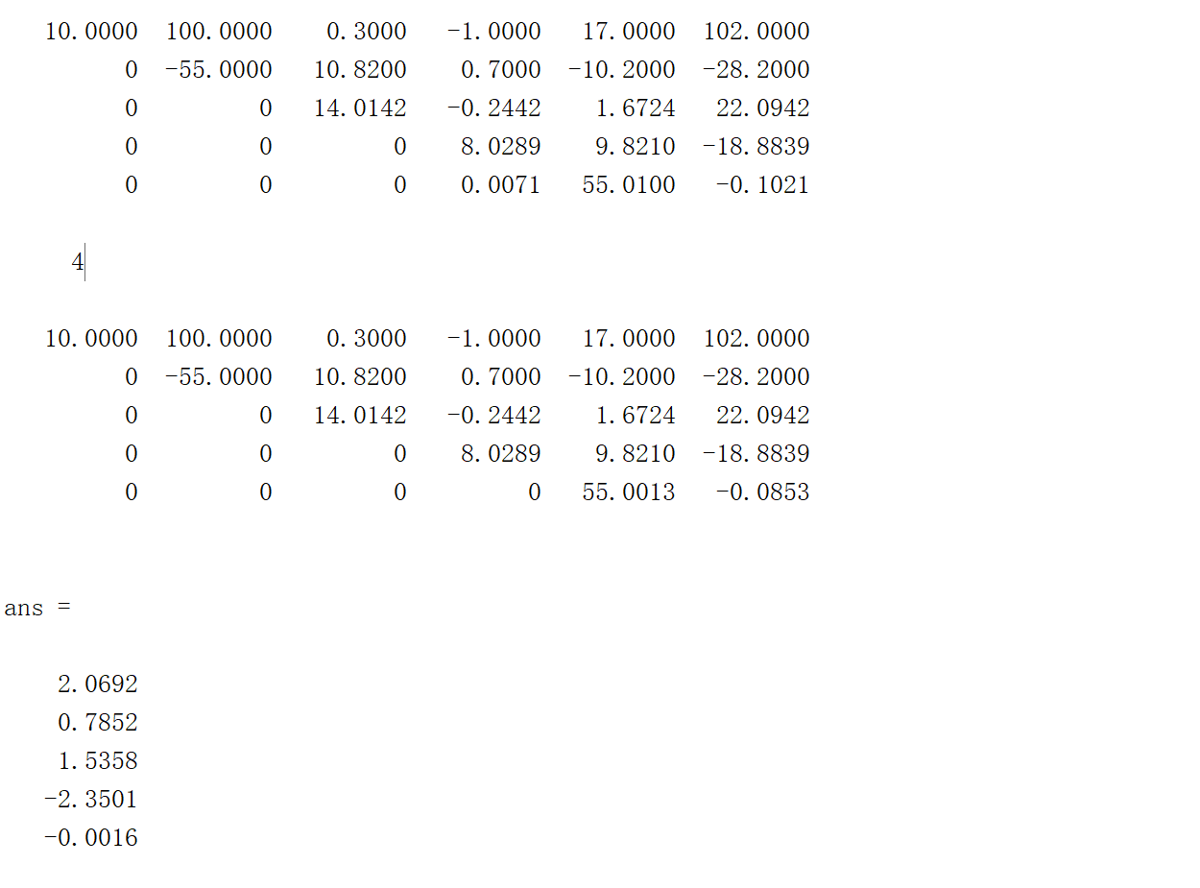

$guass_scaled_ partition_pivot:$

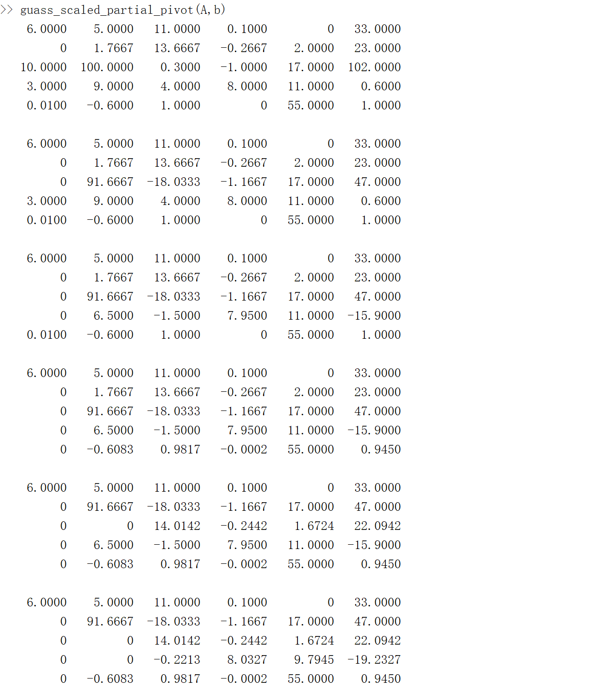

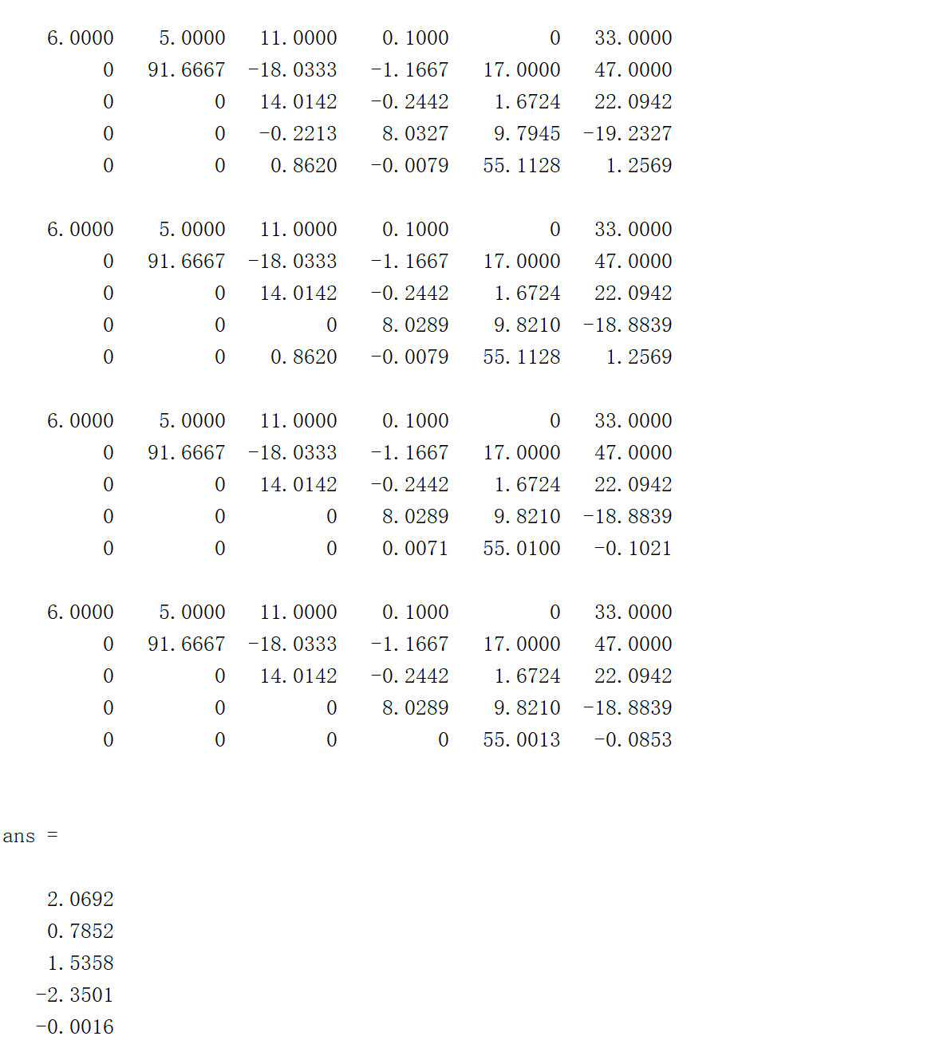

Q6.

$guass_no_pivot:$

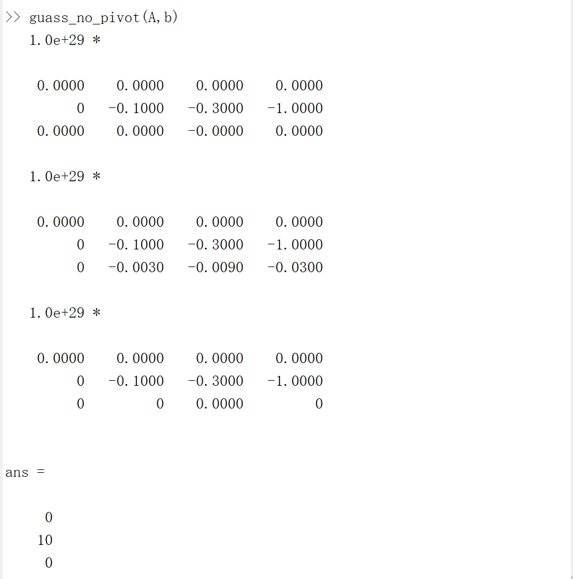

$guass_partition_pivot:$

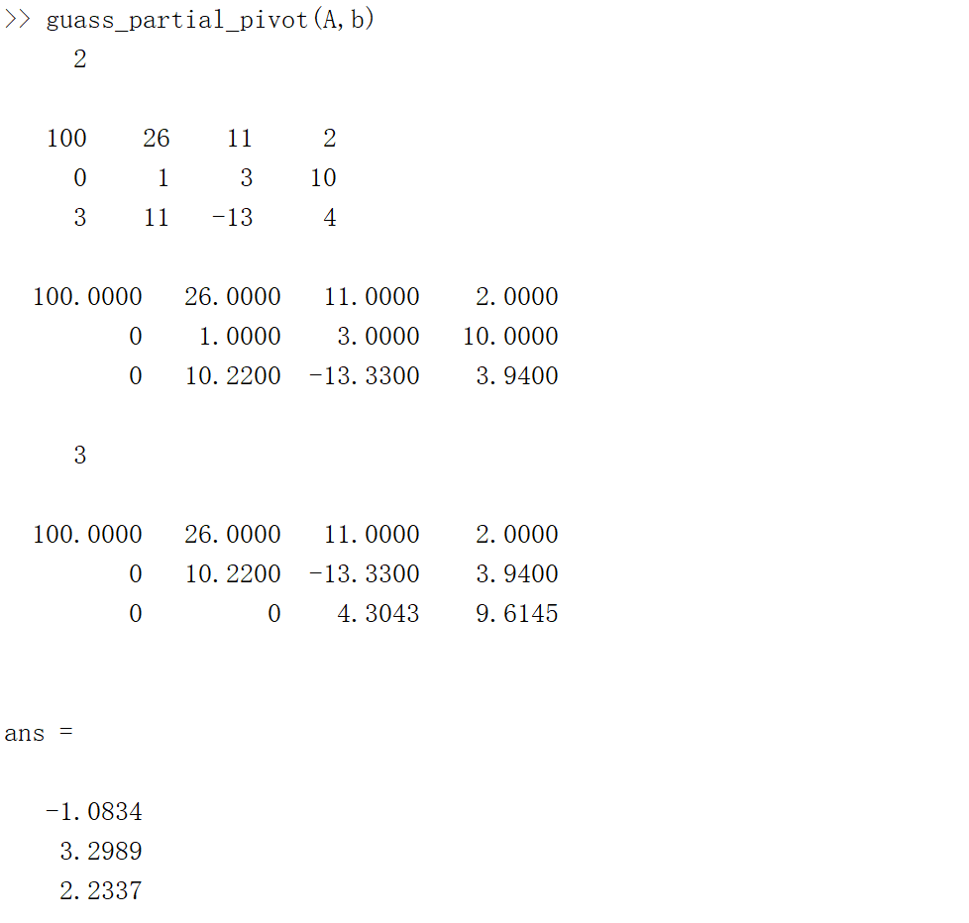

We can find that the result of two algorithms is different. In the first row, the ${10}^{-26}$ is very smaller, close to zero and if it does not exchange the rows with the $A(i, i$), $i$ is a constant. This will be beyond the accuracy of the computer. Since for each root the loss of the elimination will become larger and larger. If finding the maximum as in question 3 and swap, it will reduce the number of rounds, so they will have the different result.